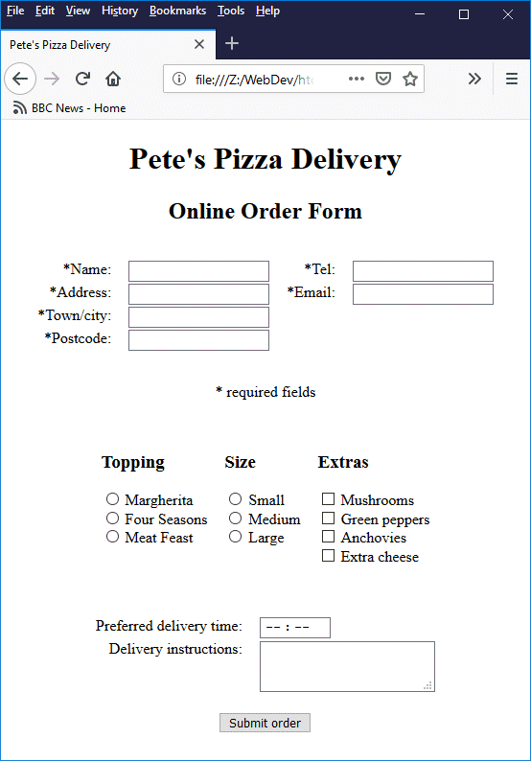

Price Details

1. Topping
   1. Margherita – RS 50
   2. Four seasons – RS 100
   3. Meat Feast - – RS 150
2. Size
   1. Small – 275
   2. Medium – 325
   3. Large - 415
3. Extras
   1. Mushrooms – 75
   2. Green Peppers – 50
   3. Anchovies – 65
   4. Extra cheese - 20

<!doctype html>  
<html lang="en">  
  
  <head>  
    <meta charset="utf-8" />  
    <title>Pete's Pizza Delivery</title>  
    <style>  
      table {margin: auto; padding: 1em;}  
      td {padding: 0 0.5em; vertical-align: top;}  
    </style>  
  </head>  
  
  <body>  
  
    <h1 style="text-align: center;">Pete's Pizza Delivery</h1>  
    <h2 style="text-align: center;">Online Order Form</h2>  
  
    <form method="post" action="">  
      <table>  
        <tr>  
          <td style="text-align: right;"><label for="name">\*Name: </label></td><td><input type="text" name="name" id="name" required /></td>  
          <td style="text-align: right;"><label for="tel">\*Tel: </label></td><td><input type="tel" name="tel" id="tel" required /></td>  
        </tr>  
        <tr>  
          <td style="text-align: right;"><label for="addr">\*Address: </label></td><td><input type="text" name="addr" id="addr" required /></td>  
          <td style="text-align: right;"><label for="mail">\*Email: </label></td><td><input type="email" name="mail" id="mail" required /></td>  
        </tr>  
        <tr>  
          <td style="text-align: right;"><label for="town">\*Town/city: </label></td><td><input type="text" name="town" id="town" required /></td>  
        </tr>  
        <tr>  
          <td style="text-align: right;"><label for="pcode">\*Postcode: </label></td><td><input type="text" name="pcode" id="pcode" required /></td>  
        </tr>  
      </table>  
  
      <p style="text-align: center;">\* required fields</p>  
  
      <table>  
        <tr>  
          <td>  
            <h3>Topping</h3>  
            <label><input type=radio name=topping id="marg" required value="marg" /> Margherita</label><br />  
            <label><input type=radio name=topping id="four" required value="four" /> Four Seasons</label><br />  
            <label><input type=radio name=topping id="meat" required value="meat" /> Meat Feast</label><br />  
          </td>  
          <td>  
            <h3>Size</h3>  
            <label><input type=radio name=base id="s" required value="s" /> Small</label><br />  
            <label><input type=radio name=base id="m" required value="m" /> Medium</label><br />  
            <label><input type=radio name=base id="l" required value="l" /> Large</label><br />  
          </td>  
          <td>  
            <h3>Extras</h3>  
            <label><input type=checkbox name=extra id="mu" value="mu" /> Mushrooms</label><br />  
            <label><input type=checkbox name=extra id="pe" value="pe" /> Green peppers</label><br />  
            <label><input type=checkbox name=extra id="an" value="an" /> Anchovies</label><br />  
            <label><input type=checkbox name=extra id="ch" value="ch" /> Extra cheese</label><br />  
          </td>  
        </tr>  
      </table>  
  
      <br />  
  
      <table>  
        <tr>  
          <td style="text-align: right;"><label for="del">Preferred delivery time: </label></td>  
          <td><input type=time min="11:00" max="21:00" step="900" name="del" id="del" required /></td>  
        </tr>  
        <tr>  
          <td style="text-align: right;"><label for="instr">Delivery instructions: </label></td>  
          <td><textarea name="instr" id="instr" maxlength=1000></textarea></td>  
        </tr>  
        <tr>  
          <td colspan="2" style="text-align: center;"><br /><button>Submit order</button></td>  
        </tr>  
      </table>  
    </form>  
  
  </body>  
</html>